Car with solid fill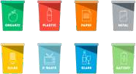TRANSPORT TO RECYCLING PLANT

CONSUMER DROPS OFFICE AND IT WASTE

CONSUMER

ELECTRONICS

COMODITY

IT COMMUNICATION

TECHNOLOGY

LARGE HOUSEHOULD APPLIANCES

OTHERS

MARKET

34% 14%

42%

10%

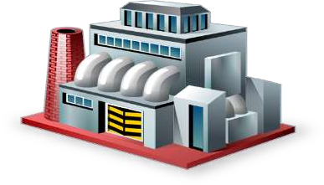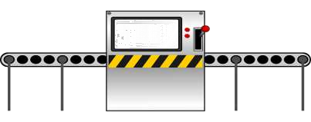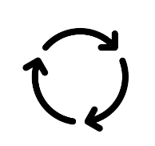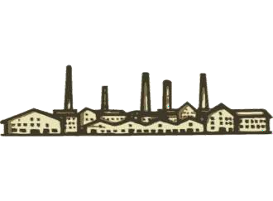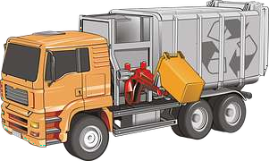

5% TSDF-AFTER RECYCLING

AS PER GOVT.NORMS REPAIR,REFURBISH

RECOVERY OF

METALS